Penn State University

Project 2 Report

Faviana Troshani &
Ian Grinarml
CMPSC 463

Professor Yang
December 5, 2025
TABLE OF CONTENTS

1 | DESCRIPTION/SIGNIFICANCE OF PROJECT | 3
2 | CODE STRUCTURE | 4
3 | DESCRIPTION/VERIFICATION OF ALGORITHM | 6
4 | FUNCTIONALITIES | 8
5 | EXECUTION RESULTS AND ANALYSIS | 9
6 | CONCLUSION | 11

DESCRIPTION/SIGNIFICANCE OF PROJECT

For this project, we were tasked with the goal of creating a project that related to the theme of weather crises in hopes of applying our knowledge of algorithmic design and analysis to address meaningful and timely problems in this domain. As a result, we decided together after a long discussion to create a resource allocation system for weather crises that optimizes distribution of limited emergency supplies using algorithmic techniques. These limited supplies include food, medical supplies, rescue teams, and shelter equipment and our application is meant to take a set of crisis-affected regions, their resource needs, available supply depots, the distances between regions, and transportation constraints.
The significance of this project revolves around the limited amount of supplies that can be brought to different areas, focusing on finding the best place to send these supplies by considering which areas need them more and prioritizing them through the use of a greedy algorithm. With this project, we will use resources as efficiently as possible so those that are in greater need can get help before focusing on others that don’t need as much help since our resources cannot be used everywhere all at once in a real life scenario.

CODE STRUCTURE

Examples of Code (More on Github):
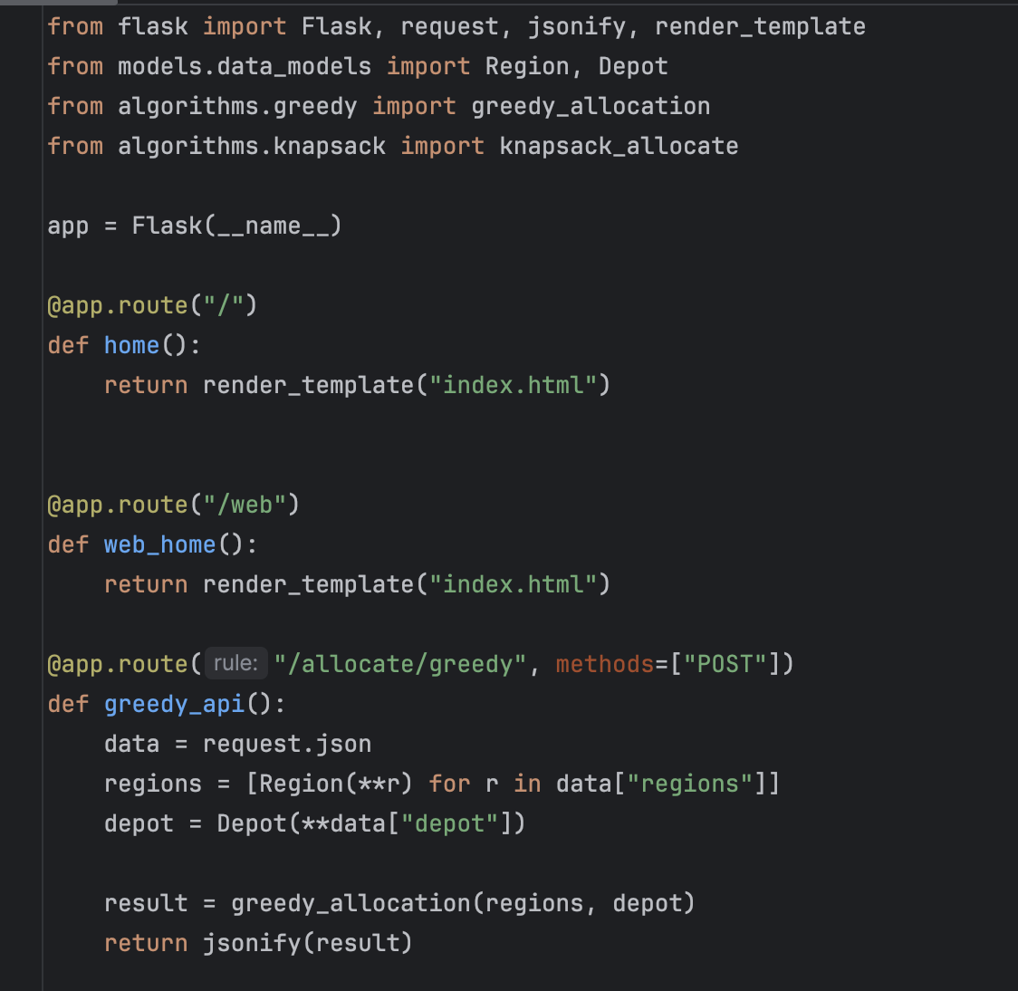
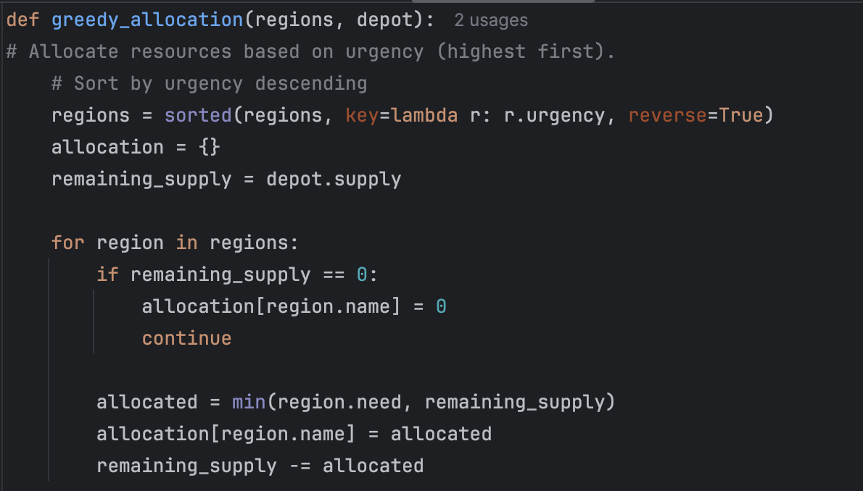

DESCRIPTION/VERIFICATION OF ALGORITHM
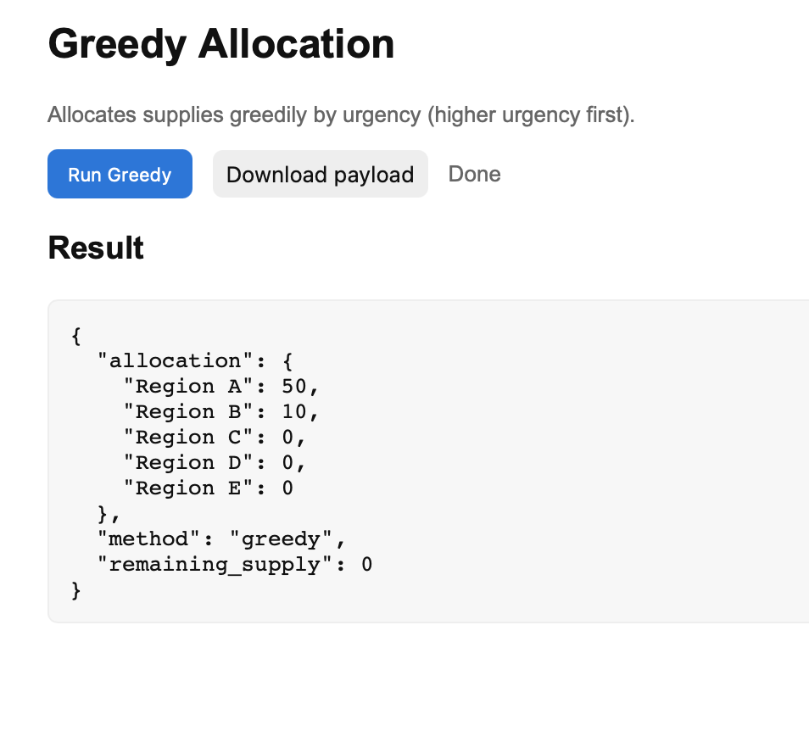
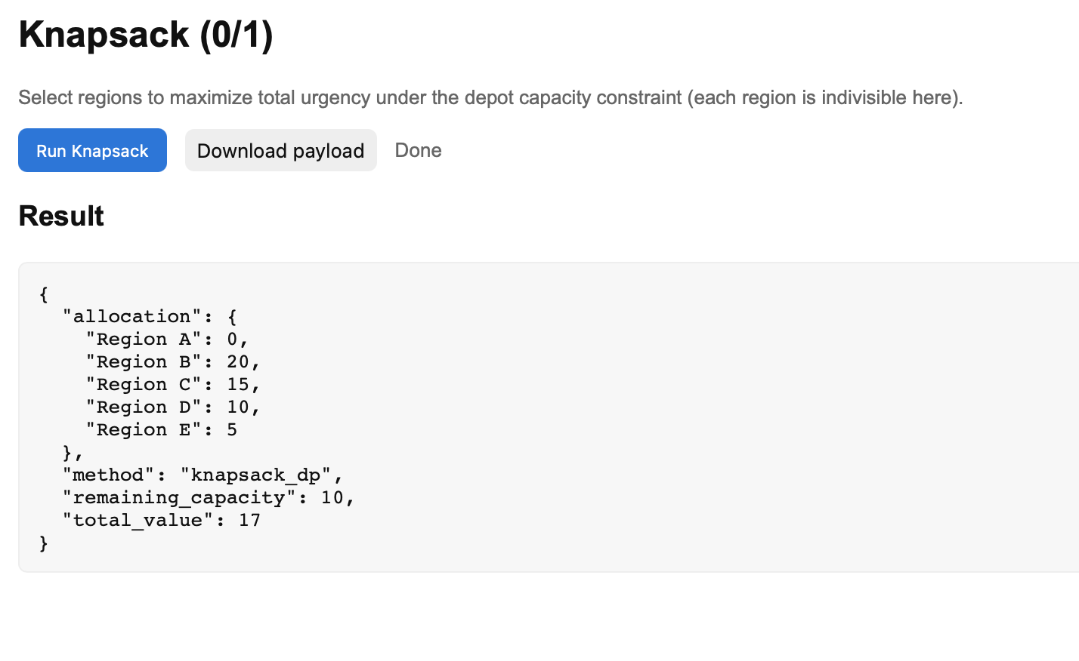
One of the main focuses of this project includes the greedy allocation algorithm that quickly distributes limited supplies to regions in a weather crisis by prioritizing the regions with the highest amount of urgency. Each region has two attributes assigned to them, need (the amount of resources that are required) and urgency (the priority score). This greedy algorithm sorts all regions in descending order of urgency and starts from the highest urgency region, allocating as many supplies until the depot runs out. This process continues until all supplies are exhausted. It is a fast algorithm that is good for real-time emergency decisions when speed matters more.
The other main focus would be the knapsack optimization (dynamic programming) which maximizes the total urgency handled given the limited supplies. It works as a classic 0/1 knapsack problem where each region represents an item, the need represents weight, urgency represents value, and depot supply represents capacity. It builds a 2D dynamic programming table and, for each region, decides whether to include it if it fits and increases urgency or excludes it if it isn’t beneficial. The algorithm then backtracks through the table to find which regions were selected, guaranteeing an optimal selection of regions under a strict supply constraint and ensures the highest-urgency combination of regions.

FUNCTIONALITIES

Core Algorithmic Functionalities include:
- Greedy Resource Allocation
  - Quickly distributes limited supplies to crisis regions by urgency.
  - How it works: Regions are sorted by urgency (highest → lowest). Supplies are allocated until the depot runs out. It is fast but not always optimal.
  - Used when speed is needed more than perfect optimization (which is most cases for crises)
- Knapsack Optimization
  - Finds the optimal combination of regions to serve when supplies are insufficient.
  - How it works: Treat each region as an item (weight = resources needed, value = urgency score). Runs the 0/1 knapsack DP algorithm. Selects the best mix of regions to maximize total urgency handled.
  - Used when we need the best possible allocation under strict supply limits.
Output & Visualization Functionalities:
- Real-Time Results:
  - The web interface shows: Detailed allocation decisions, Remaining supply/capacity, Total urgency handled (knapsack), Algorithm Comparison Users can compare:
  - Greedy vs DP optimality, Greedy vs DP resource usage. This demonstrates algorithmic tradeoffs — a key academic goal.

EXECUTION RESULTS AND ANALYSIS

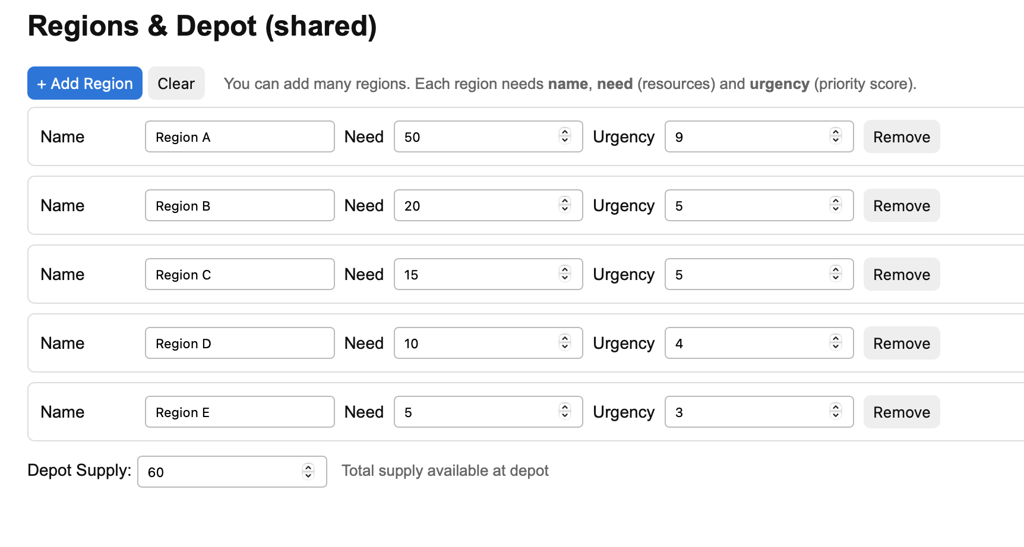
We tested both Greedy and Knapsack algorithms with the above input.

The Greedy algorithm sorts regions based purely on their urgency rating first, then organizes resources until the depot runs out. Region A and B relieve support because they have the highest urgency. However, the remaining regions are left without any supplies due to them individually having less urgent demand. This works well when you have enough resources to go around by targeting the most urgent demand first and sending supplies, and takes quality over quantity. This is the case even if it doesn’t have enough supplies to fully meet Region B, it still ignores the regions it could have fully supplied.

Meanwhile, Knapsack finds the combination of regions whose demands it can fully meet that maximize the total urgency. Here it ignores Region A despite its high urgency since it can supply all the other Regions which in total have a higher urgency and even keeps resources in reserve since it can’t fully meet the demand of Region A with its remaining resources. This could help in more long term planning as it can help keep resources available for future regions that need help that it could fully supply.

CONCLUSION

Throughout this project, the two of us have worked together and have been able to create something that could further be evolved into something extremely useful if taken into greater hands with more time. Neither of us have much experience when it comes to web development so our project lands somewhat flat on that regard, but the code that we have used demonstrates topics that we have learned in class such as the greedy algorithm. This project shows that algorithmic designs play a crucial role in addressing challenges of modern weather crises, especially when deciding what region needs to be prioritized for supplies.
Our findings of this project highlight several key insights. This includes the accuracy and usefulness of evacuation routing depending heavily on the quality of the data where even simple models can improve safety significantly when incorporated into pathfinding algorithms. Overall, it illustrates how multiple algorithmic components can be integrated into a unified system to support time-critical decisions. Alongside our success, we also faced several issues and limitations. One constraint would be the reliance on simplified data, limiting the realism and predictive accuracy of the model as real weather-crisis systems require continuous updates and high-resolution environmental data. Another issue this project faces is the lack of visualization on the web application, only providing stats compared to a graph that could be shown instead.
While this is just a project created in the time that we had, it successfully illustrates how the information that we learned in this class can be transformed into useful computational tools that are relevant in society. If refined and with the incorporation of real-time environmental data, this project could evolve into an impactful decision support application that will help many regions facing disasters from weather crises.

